Task 5.1: Create a Spring boot project with necessary dependencies and Configure JDBC ,Connection in data source explorer.
Step 1: Create Spring Boot Project
File → New → Spring Starter Project → Packaging → WAR
Dependencies :
Spring Web
Spring Data JDBC
MySQL Driver
Project Structure Image:
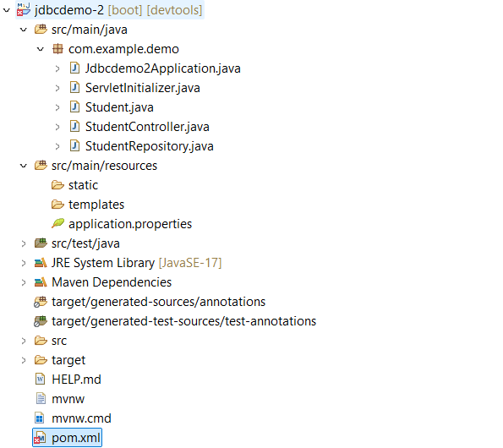

Pom.xml file:
<?xml version="1.0" encoding="UTF-8"?>
<project xmlns="http://maven.apache.org/POM/4.0.0" xmlns:xsi="http://www.w3.org/2001/XMLSchema-instance"
xsi:schemaLocation="http://maven.apache.org/POM/4.0.0 https://maven.apache.org/xsd/maven-4.0.0.xsd">
<modelVersion>4.0.0</modelVersion>
<parent>
<groupId>org.springframework.boot</groupId>
<artifactId>spring-boot-starter-parent</artifactId>
<version>4.0.2</version>
<relativePath/> <!-- lookup parent from repository -->
</parent>
<groupId>com.example</groupId>
<artifactId>jdbcdemo-2</artifactId>
<version>0.0.1-SNAPSHOT</version>
<packaging>war</packaging>
<name>jdbcdemo-2</name>
<description>Demo project for Spring Boot</description>
<url/>
<licenses>
<license/>
</licenses>
<developers>
<developer/>
</developers>
<scm>
<connection/>
<developerConnection/>
<tag/>
<url/>
</scm>
<properties>
<java.version>17</java.version>
</properties>
<dependencies>
<dependency>
<groupId>org.springframework.boot</groupId>
<artifactId>spring-boot-starter-data-jdbc</artifactId>
</dependency>
<dependency>
<groupId>com.mysql</groupId>
<artifactId>mysql-connector-j</artifactId>
<scope>runtime</scope>
</dependency>
<dependency>
<groupId>org.springframework.boot</groupId>
<artifactId>spring-boot-starter-data-jdbc</artifactId>
</dependency>
<dependency>
<groupId>org.springframework.boot</groupId>
<artifactId>spring-boot-starter-webmvc</artifactId>
</dependency>
<dependency>
<groupId>org.springframework.boot</groupId>
<artifactId>spring-boot-devtools</artifactId>
<scope>runtime</scope>
<optional>true</optional>
</dependency>
<dependency>
<groupId>com.mysql</groupId>
<artifactId>mysql-connector-j</artifactId>
<scope>runtime</scope>
</dependency>
<dependency>
<groupId>org.springframework.boot</groupId>
<artifactId>spring-boot-starter-tomcat</artifactId>
<scope>provided</scope>
</dependency>
<dependency>
<groupId>org.springframework.boot</groupId>
<artifactId>spring-boot-starter-data-jdbc-test</artifactId>
<scope>test</scope>
</dependency>
<dependency>
<groupId>org.springframework.boot</groupId>
<artifactId>spring-boot-starter-webmvc-test</artifactId>
<scope>test</scope>
</dependency>
</dependencies>
<build>
<plugins>
<plugin>
<groupId>org.springframework.boot</groupId>
<artifactId>spring-boot-maven-plugin</artifactId>
</plugin>
</plugins>
</build>
</project>
Step 2: Configure Database (application.properties)
spring.application.name=jdbcdemo-2
spring.datasource.url=jdbc:mysql://localhost:3306/studentdb
spring.datasource.username=root
spring.datasource.password=computer
spring.datasource.driver-class-name=com.mysql.cj.jdbc.Driver
spring.jpa.hibernate.ddl-auto=update
spring.jpa.show-sql=true

Step 3: Create Database in MySQL
create database studentdb;
use studentdb;
create table student(
id int primary key,
name varchar(50),
email varchar(100),
department varchar(50)
);
Step 4: Main Class
Jdbcdemo2Application.java
package com.example.demo;
import org.springframework.boot.SpringApplication;
import org.springframework.boot.autoconfigure.SpringBootApplication;
@SpringBootApplication
public class Jdbcdemo2Application {
public static void main(String[] args) {
SpringApplication.run(Jdbcdemo2Application.class, args);
}
}

Step 5: Create Entity Class (Student)
Right click → New → Class
Name: Student
Package: com.example.demo
package com.example.demo;

public class Student {
private int id;
private String name;
private String email;
private String department
// Constructors
public Student() {}
public Student(int id, String name, String email, String department) {
this.id = id;
this.name = name;
this.email = email;
this.department = department;
}
// Getters and Setters
public int getId() { return id; }
public void setId(int id) { this.id = id; }
public String getName() { return name; }
public void setName(String name) { this.name = name; }

public String getEmail() { return email; }
public void setEmail(String email) { this.email = email;
public String getDepartment() { return department; }
public void setDepartment(String department) { this.department = department; }
}
Step 6: Create Repository Interface
Right click → New → Interface
Name: StudentRepository
package com.example.demo;
import org.springframework.beans.factory.annotation.Autowired;
import org.springframework.jdbc.core.JdbcTemplate;
import org.springframework.stereotype.Repository;
@Repository
public class StudentRepository {
@Autowired
private JdbcTemplate jdbcTemplate;
public int insertStudent(Student student) {
String sql = "INSERT INTO student VALUES (?, ?, ?, ?)";
return jdbcTemplate.update(sql,
student.getId(),
student.getName(),
student.getEmail(),
student.getDepartment());
}
}
Step 7:Create Controller Class
Right click → New → Class
Name: StudentController
package com.example.demo;
import org.springframework.beans.factory.annotation.Autowired;
import org.springframework.web.bind.annotation.*;
@RestController
@RequestMapping("/student")
public class StudentController {
@Autowired
private StudentRepository repository;
@PostMapping("/add")
public String addStudent(@RequestBody Student student) {
repository.insertStudent(student);
return "Student Added Successfully!";
}
}

Step 8: Run Application
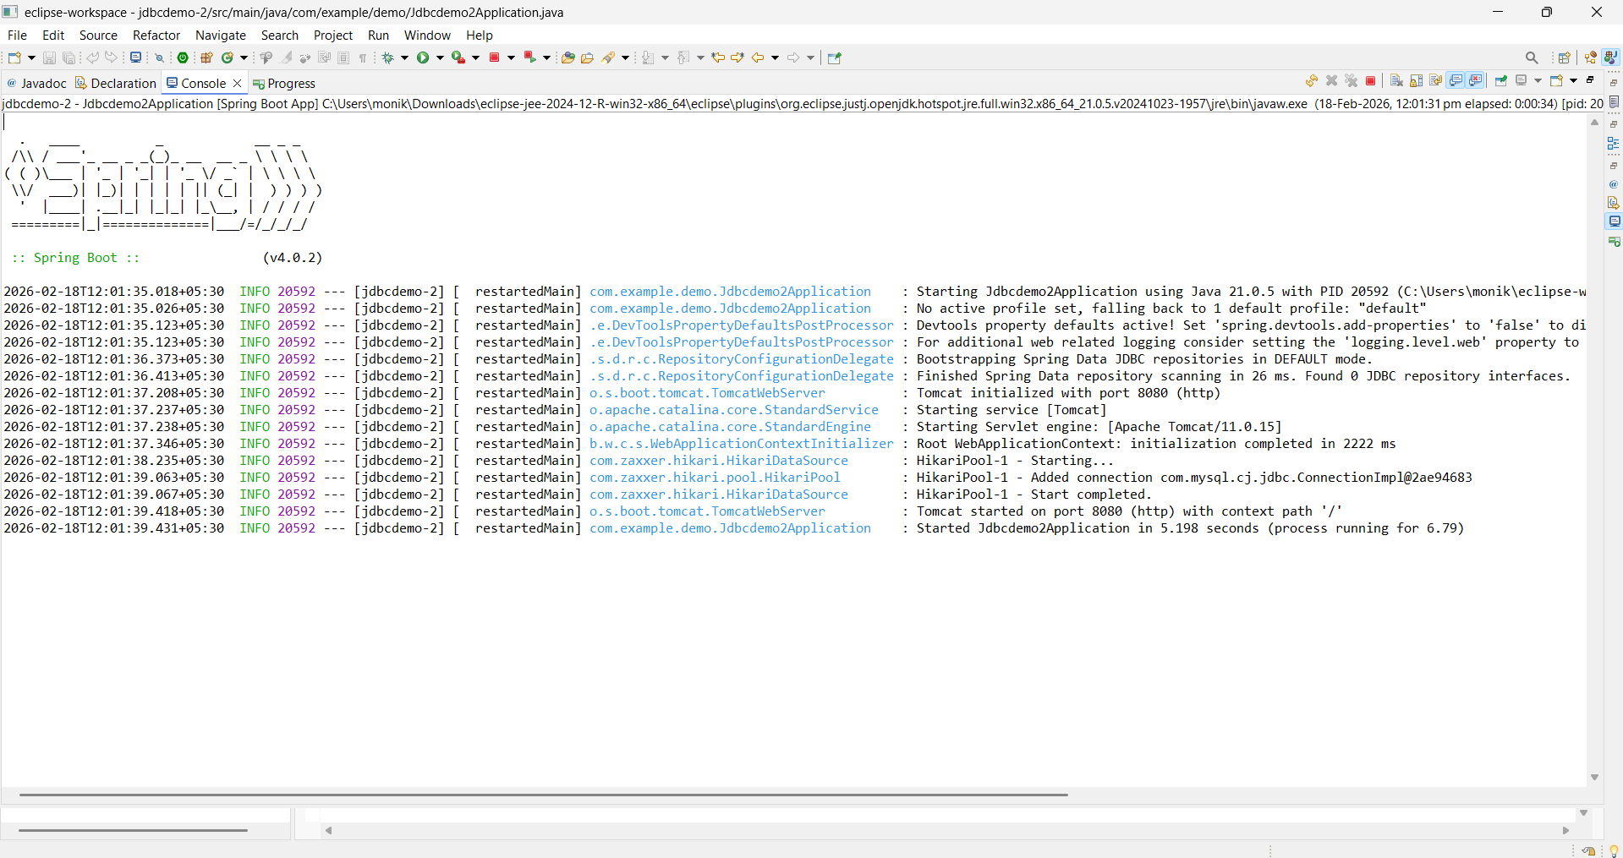

Step 9: Test Using Postman
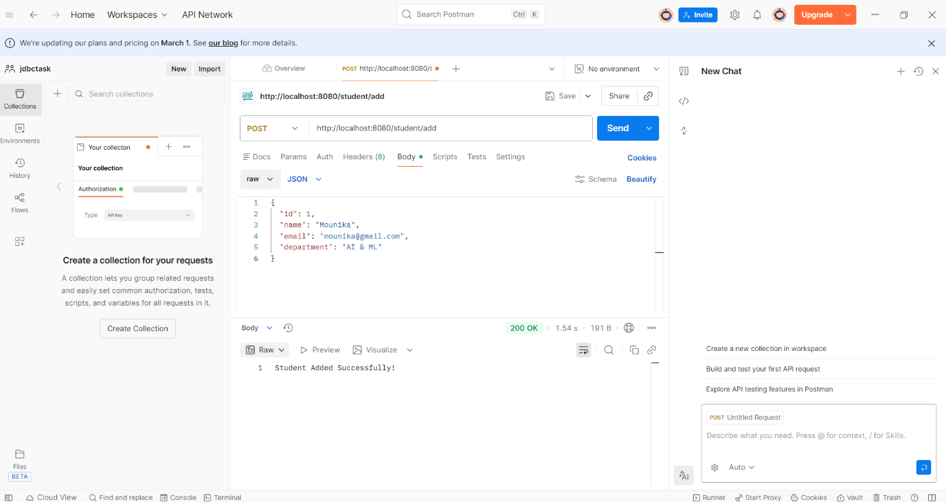
Step 10: Verify in MySQL
